# Pivot Temperature by City and Year

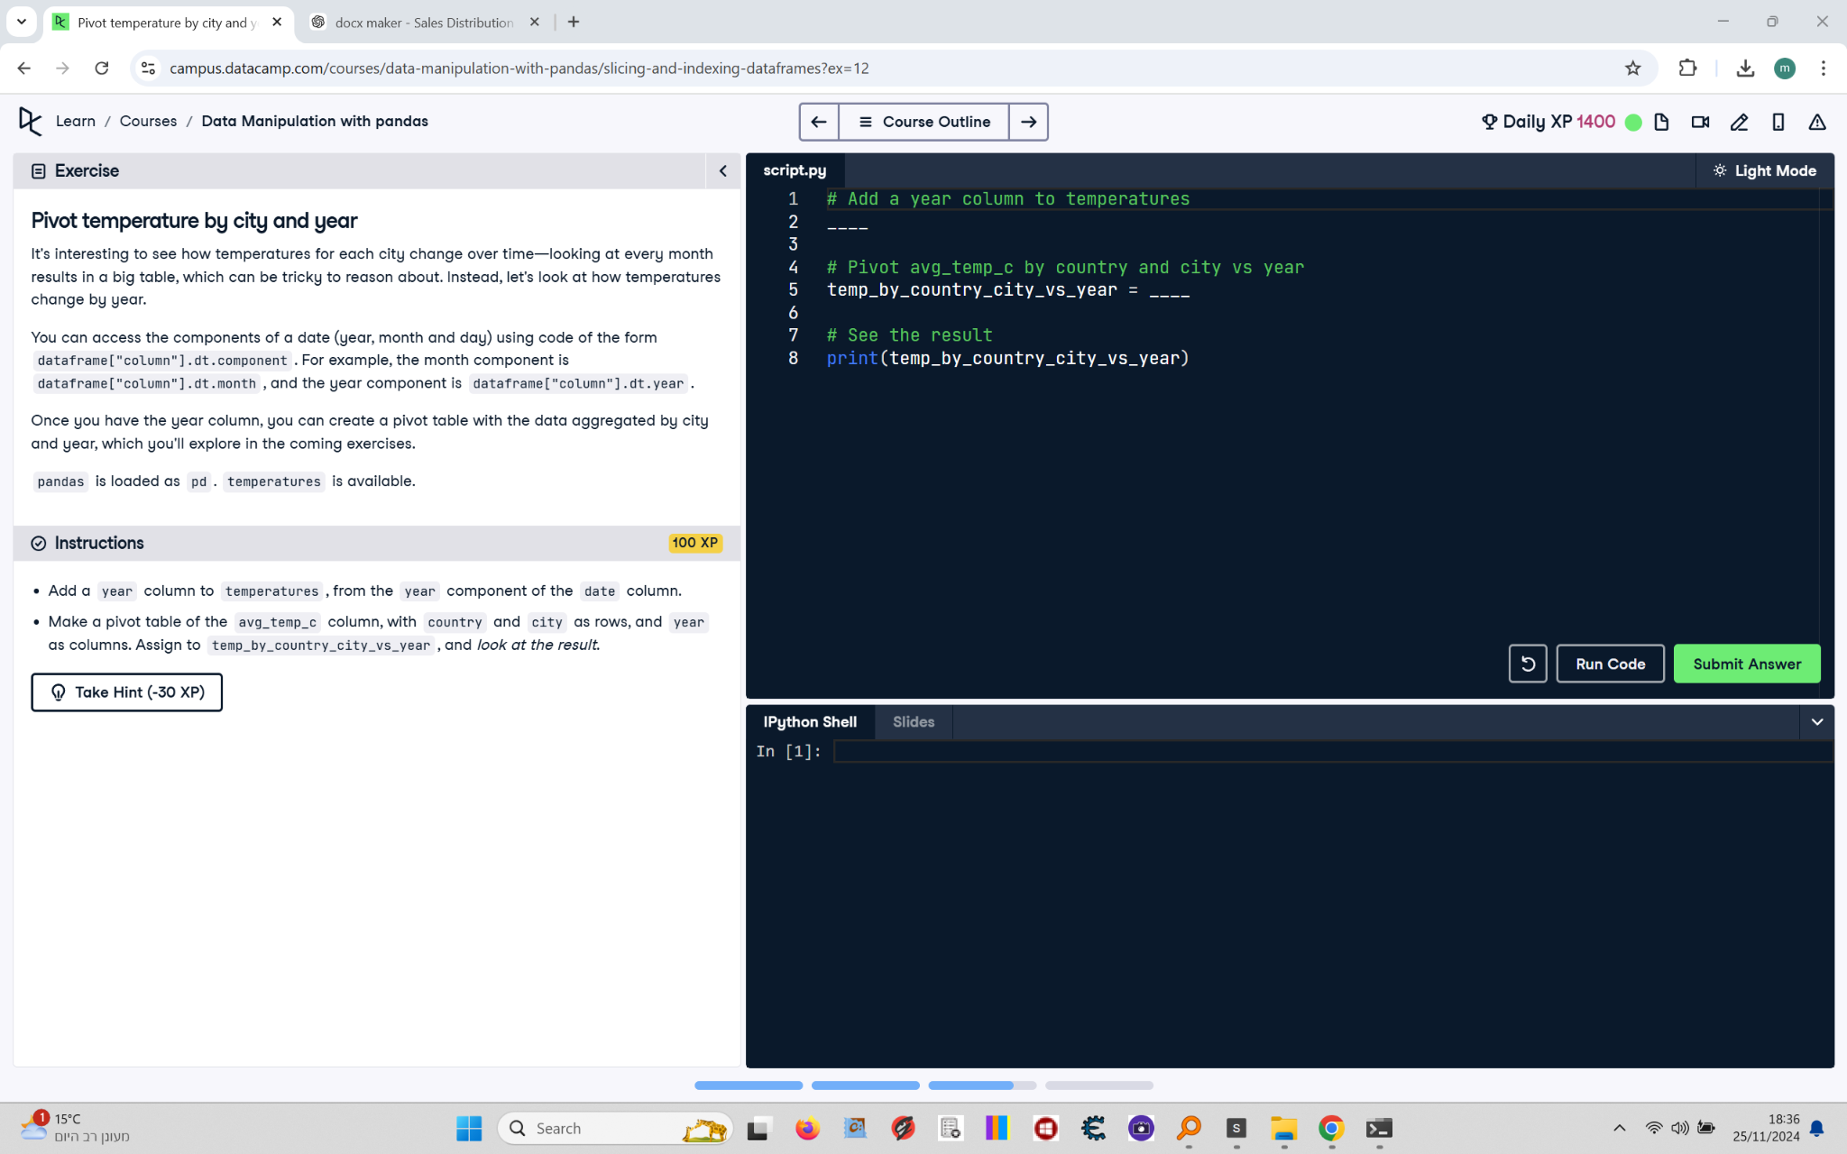

It's interesting to see how temperatures for each city change over time—looking at every month results in a big table, which can be tricky to reason about. Instead, let's look at how temperatures change by year.  
  
You can access the components of a date (year, month, and day) using code of the form dataframe['column'].dt.component. For example, the month component is dataframe['column'].dt.month, and the year component is dataframe['column'].dt.year.  
  
Once you have the year column, you can create a pivot table with the data aggregated by city and year, which you'll explore in the coming exercises.  
  
pandas is loaded as pd. temperatures is available.

## Final Answer

# Add a year column to temperatures  
temperatures["year"] = temperatures["date"].dt.year  
  
# Pivot avg_temp_c by country and city vs year  
temp_by_country_city_vs_year = temperatures.pivot_table(  
 values="avg_temp_c",  
 index=["country", "city"],  
 columns="year"  
)  
  
# See the result  
print(temp_by_country_city_vs_year)